273/1

**GEOGRAPHY**

**Paper 1**

July/August 2024

2¾ hours



WESTERN JOINT MOCK EXAMINATIONS

Uganda Certificate of Education

**GEOGRAPHY**

**Paper 1**

2 hours 45 minutes

**INSTRUCTIONS TO CANDIDATES:**

* *This paper consists of* ***two*** *sections* ***A*** *and* ***B****. It has* ***six*** *examination items.*
* *Section* ***A*** *has* ***two*** *compulsory items.*
* *Section* ***B*** *has* ***two*** *parts,* ***I*** *and* ***II****. Answer* ***one*** *item in each part.*
* *Answer* ***four*** *examination items in all.*
* *You may use diagrams where applicable to illustrate your answers.*
* *Any additional item(s) answered will* **not** *be scored.*
* *All answers* ***must*** *be written in the answer booklet(s) provided.*

**SECTION A: MAP AND PHOTOGRAPH SKILLS**

*Answer* ***all*** *items in this section*

**Item 1: Map skills**

For this item, use the East Africa 1: 50,000 (Uganda) Map Extract of Lukaya Series Y732, Sheet 79/2, Edition 3 – U.S.D, the information in the text below to answer the tasks given.

1. Madam Shallon lives in Lukaya trading centre South East of Mutumba II at Grid reference **750844** in the Southern part of the area shown on the map extract. Whenever she is travelling, she picks the motorcycle from the trading centre of Lukaya. She works at Buganga as a secondary school teacher of Geography at Grid reference **876950**. If the cost of travelling by motorcycle on the road is shs6,000 per kilometer;

**Task:**

Determine how much amount of money Shallon will spend on the journey.

(*02 scores*)

1. A Ugandan investor called Mr. Tom obtained a loan from ABSA Financial Institution to set up Coffee Estate and a processing factory in the area shown on the 1: 50,000 (East Africa) UGANDA map extract Lukaya. Unfortunately, the investor cannot find suitable area for coffee estate and the factory because of various relief features in the area. He has been advised by his friend a suitable area for the estate and industry by providing him with the vital information about relief of the area (*provide the learners with Lukaya Map extract*.)

**Task:**

Using the sketch map drawn and evidence from the map extract provided, advise the investor on the necessary information. (*08 scores*)

**Item 2: Photograph skills**

Study **Fig. 2**; a photograph taken from one of the places in Investor Uganda and text provided below it.

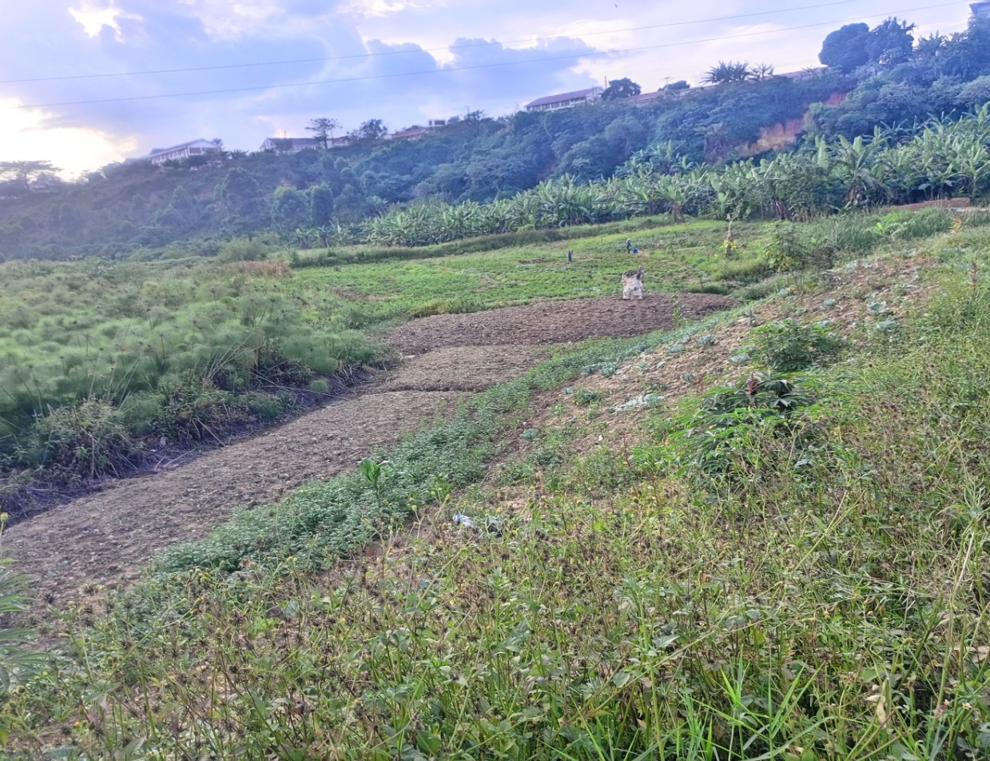

You are working with safari Tours and Travel Company Limited as a tour guide. A group of British tourists are planning to visit Uganda. They have booked Safari Company to help them tour certain areas of interest. The company manager is of the view that the tourists visit the area shown in the photograph.

**Task:**

1. Draw a landscape sketch of the photograph an on it mark and name the features found in the area shown in the photograph. (*06 scores*)
2. Describe for the visitors the attractions they will see and the activities they will engage in when they visit the area. Give evidence from the photograph.

(*02 scores*)

1. Explain **four** reasons why you would recommend a tourist coming to east Africa to visit the area shown in the photograph. (*02 scores*)

**SECTION B**

**Part I:** *Answer* ***one*** *item from this part*

**Item 3:**

Study the text and **figure 3** provided and use them to answer this item.

Atienga Muhammad and his family have been living in British Columbia as fish mongers for the last four years. The family plans to return to East Africa and establish their home in any one of the relief regions where they can carry out fishing activities. However, they have little knowledge about the geography of East Africa.

**Support material: Map of East Africa showing relief regions**



**Fig. 3**

**Task:**

Write an essay of about 300 – 400 words advising Atienga Muhammad and his family on where they can settle and carry out fishing activities. (*10 scores*)

**Item 4:**

Study the **table I** below. Showing data delivered from one of the weather stations on the shores of Lake Victoria and answer the questions that follow.

|  |  |  |  |  |  |  |  |  |  |  |  |  |
| --- | --- | --- | --- | --- | --- | --- | --- | --- | --- | --- | --- | --- |
| **Month** | **J** | **F** | **M** | **A** | **M** | **J** | **J** | **A** | **S** | **O** | **N** | **D** |
| **Temp ($℃)$** | 20 | 21 | 22 | 22 | 21 | 20 | 20 | 20 | 22 | 22 | 21 | 20 |
| **Rainfall (mm)** | 30 | 40 | 128 | 198 | 200 | 50 | 54 | 98 | 140 | 220 | 150 | 40 |

1. Using the graph paper provided, neatly draw a climatic graph to portray the above data. (*04 scores*)
2. A group of local farmers in the area where the station is found have just received funds from the government under the Parish Development Model (PDM) scheme. They wish to carry out a farming project of growing crops.

Among the activities they are expected to do are; clearing the land, ploughing, preparation of seeds, planting, spraying, weeding.

As somebody who has learnt and understood the influence of climate on human activities, design a farm calendar to help these local farmers plan, coordinate and effectively carry out farming activities throughout the year. (*03 scores*)

1. In your analysis, prove that you not support your friend to settle in such an area where this station is located. (*01 score*)
2. From the above table, determine the following.
3. Annual range of temperature
4. Mean annual temperature
5. Mean annual rainfall
6. The driest month of the station

(*02 scores*)

**Part II:** *Answer* ***one*** *item from this part*

**Item 5:**

Majority of the rural population in Uganda derives their energy from Bio mass (firewood and charcoal). This contributes 90% of the population. According to the current status of forestry in Uganda, the demand for wood fuel is estimated to have increased by 9.1% between 2015-2019. This has translated into massive acres of forests and wood lands being cleared for fire wood and charcoal leading to climate change. (*Source: The New Vision, Newspaper February 19th 2023*)

**Task:**

You have been appointed as forestry officer in charge of protection and conservation of forests in Uganda, write an article of between 250 – 300 words to be published in one of the local Newspaper on how to minimize the rate of forest destruction.

(*10 scores*)

**Item 6:**

Study table II below, showing Uganda’s mineral production (Pozzolana materials) in metric tons (2000 – 2003) and answer the questions that follow.

**Table II**

|  |  |
| --- | --- |
| **Year** | **Quantity (tons)** |
| 2000 | 35,602 |
| 2001 | 22,782 |
| 2002 | 12,388 |
| 2003 | 6,587 |
| Total | 77,359 |

*Adapted: State of the Environment report for Uganda 2004 – 2005 P106*

**Task:**

1. Draw a bar graph to represent the information in the table. (*06 scores*)
2. As a student of Geography, write an article between 250 – 300 words to be published advising the community on the measures that can be under taken to promote the mining sector in the area. (*04 scores*)

**END**